

Photometric Test Report

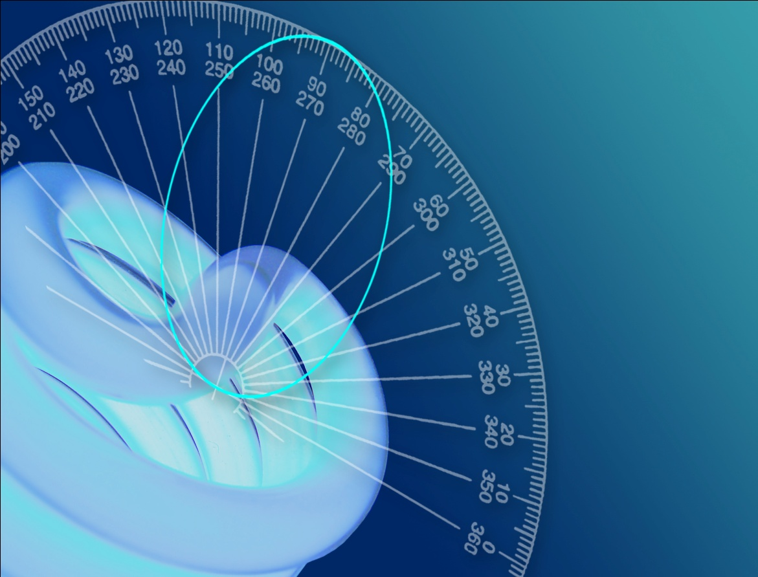

Photometric and Optical Testing Services

Cotswold Business Centre

42 A P Ellis Road  
Rissington Business Park  
Upper Rissington  
Gloucestershire  
GL54 2QB  
UK

Tel: 01451 812 222

Fax: 01451 812 201

|  |  |  |
| --- | --- | --- |
| **Photometric Test Report** | | |
| Report Number: POTS/DC13378 | Report Date: 25/11/2013 | Prepared By: D CHAMBERS |
| Test Laboratory: Photometric and Optical Testing Services, Cotswold Business Centre, 42 A P Ellis Road, Rissington Business Park, Upper Rissington, Gloucestershire, GL54 2QB | | |
| Company Registration Number: Registered in England & Wales No. OC352911 | | |
| Registered Address: Thistle Down Barn, Holcot Lane, Sywell, Northampton, NN6 0BG | | |

|  |  |
| --- | --- |
| **Client Details** | |
| Company: FAR EASTERN MANUFACTURING | Email: laura@traypoint.com |
| Address: Far Eastern Manufacturing Ltd, Major House, Unit B, 964 North Circular Road, London, NW2 7JR | |

|  |  |
| --- | --- |
| **Details of Product Tested** | |
| Manufacturer: FAR EASTERN MANUFACTURING | Source Type: LED |
| Model: COB SPOTLIGHT | Luminaire Type: GU10 SPOTLIGHT |
| Power Supply Used: Uninterruptible AC power supply | |
| Voltage(AC V) = 230 | Current (mA)= 40 |
| Power (Watts)= 7.09 | Power factor= 0.770 |

|  |  |  |
| --- | --- | --- |
| **Integrating Sphere Test** | | |
| Date of Test: 25/11/2013 | | Ambient Temperature:25°C |
| Measurement Filename: COB SPOTLIGHT | | |
| Instrument Used: Labsphere model CSLMS HALOGEN 4060 integrating sphere spectroradiometer | | |
| Integrating Sphere Size: 1m | | Measurement Geometry (2π / 4π): 2π |
| Sample Orientation: Horizontal | | Auxiliary Correction Applied: YES |
| Comments: | | |
|  | | |
| Date of Last Calibration (Operating Hours): 08-11-2012 (02:36) | | Spectral Flux Standard Lamp Used: SCL-1400 |
| Standard Lamp Serial Number: K75 | | Traceable: to NIST standards |
| Calibration Certificate Number: DM-02008-001 | | Calibration Certificate Date: 19th February 2010 |
| Calibration Lamp Uncertainty: ± 0.67% (*k=2)* | | |
| **Results** |  | |
| Flux (lumens): 489 | |  |
| CIE 1931 Chromaticity Cx: 0.4416 | | CIE 1931 Chromaticity Cy: 0.4153 |
| CRI (%):59.24 | | CCT (K): 3010 |

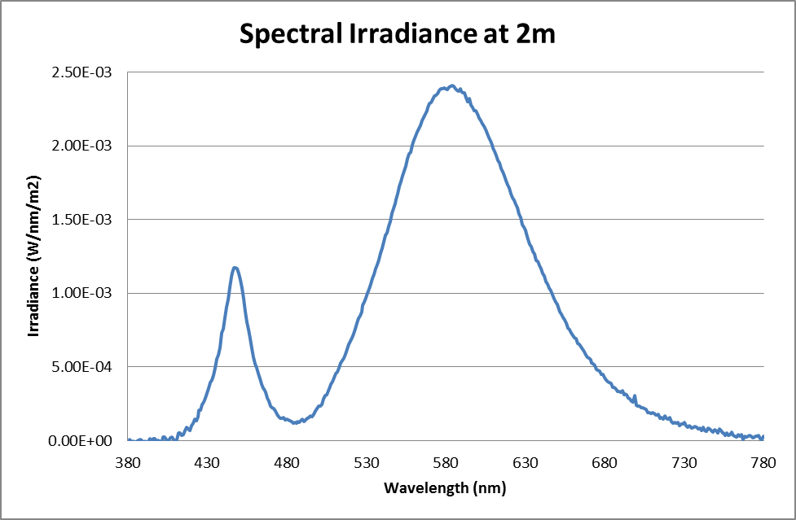

Figure 1: Spectral Irradiance

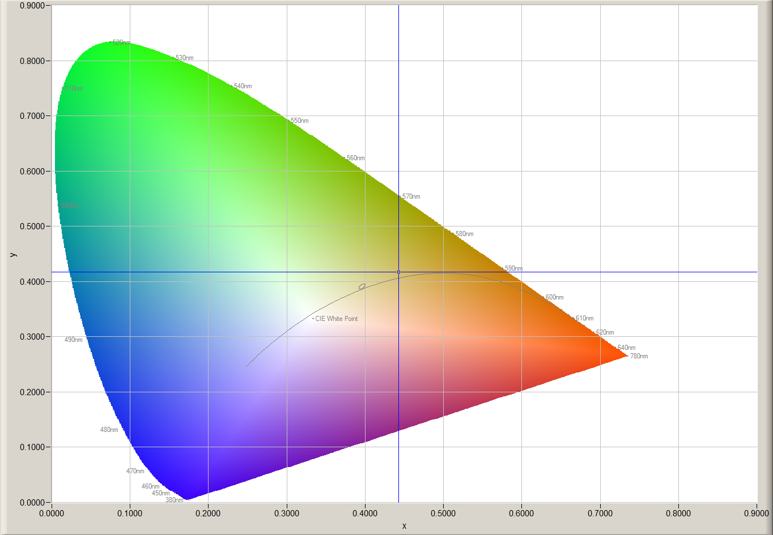

Figure 2: CIE 1931 diagram.

|  |  |  |  |
| --- | --- | --- | --- |
| **Goniophotometer Test** | | | |
| Date of Test: 25/11/2013 | | Ambient Temperature: 25°C | |
| Measurement Filename: COB SPOTLIGHT | | | |
| Instrument Used: Radiant Imaging NFMS0800 Goniometer with ProMetric PM-1200N-1 Imaging Photometer | | | |
| Photometer Working Distance: 2m | | Measurement Geometry: Near-Field | |
| Comments: | | | |
| Reference Photometer Used: Specbos1201 | | Reference Photometer Serial Number: 2911670 | |
| Traceable: to NPL standards, UKAS Accredited | | Calibration Certificate Number: 13201 | |
| Calibration Certificate Date: 15th March 2013 | | Sample Stabilisation Time (minutes): 60 | |
| Reference Photometer Calibration Uncertainty: ± 2.4% (*k=2*, 20-200 lux, CIE illuminant A source) | | | |
| **Scan Set Up** | | | |
| **Direction** | **Range** | | **Increment** |
| Inclination Zone 1 | 0-90° | | 3° |
| Azimuth | 0-360° | | 10° |
| **Results** |  | |  |
| Integrated Luminous Flux (lumens):489 | Peak Intensity (3° Spot, candelas): 453 | | Efficacy (lumens/Watt): 69 |
| Beam Angle (50% of max intensity C0-180, degrees): 50.1 | | | |
| Photometric Filename (IES LM-63-2002): COB SPOTLIGHT | | | |
| IES File – Absolute or Relative Format? Relative | | | |
| Photometric Filename (EULUMDAT): COB SPOTLIGHT | | | |
| EULUMDAT File – Absolute or Relative Format? Relative | | | |

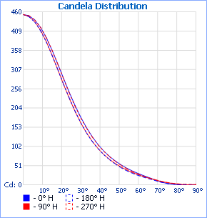

Figure 3: Far-Field Luminous Intensity (C0-180, Cartesian Coordinates)

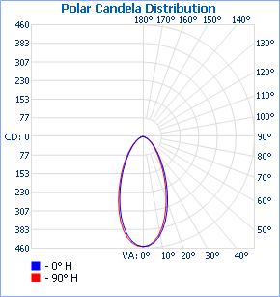

Figure 4: Far-Field Luminous Intensity (C0-180, C90-270, Polar Coordinates)

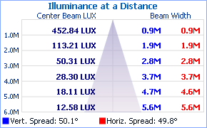

Figure 4. Cone diagram for mounting height of 6 metres.

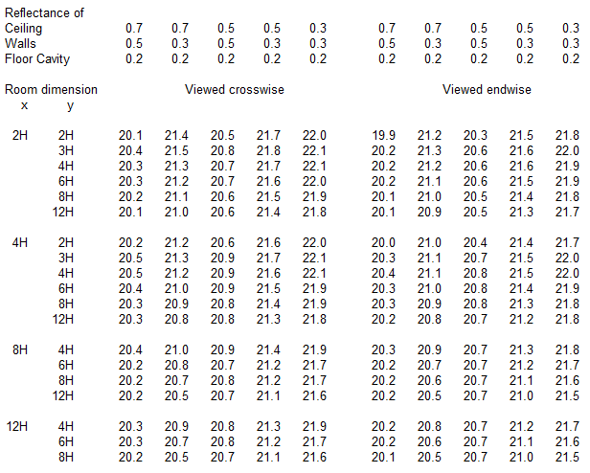

Table 1. UGR values

|  |  |  |  |  |  |  |  |  |  |  |  |  |  |  |  |  |  |  |  |
| --- | --- | --- | --- | --- | --- | --- | --- | --- | --- | --- | --- | --- | --- | --- | --- | --- | --- | --- | --- |
|  | **0** | **10** | **20** | **30** | **40** | **50** | **60** | **70** | **80** | **90** | **100** | **110** | **120** | **130** | **140** | **150** | **160** | **170** | **180** |
| **0** | 453 | 453 | 453 | 453 | 453 | 453 | 453 | 453 | 453 | 453 | 453 | 453 | 453 | 453 | 453 | 453 | 453 | 453 | 453 |
| **3** | 450 | 450 | 449 | 450 | 449 | 449 | 448 | 448 | 448 | 448 | 447 | 447 | 447 | 447 | 447 | 447 | 446 | 447 | 447 |
| **6** | 439 | 438 | 439 | 438 | 437 | 436 | 436 | 435 | 434 | 434 | 433 | 433 | 433 | 432 | 432 | 433 | 433 | 432 | 433 |
| **9** | 419 | 417 | 418 | 416 | 415 | 414 | 414 | 413 | 412 | 411 | 411 | 410 | 409 | 408 | 407 | 407 | 409 | 408 | 410 |
| **12** | 391 | 390 | 389 | 388 | 390 | 387 | 385 | 383 | 382 | 381 | 380 | 379 | 378 | 378 | 379 | 376 | 376 | 377 | 380 |
| **15** | 358 | 356 | 356 | 355 | 353 | 353 | 349 | 348 | 345 | 345 | 343 | 343 | 341 | 341 | 340 | 340 | 341 | 341 | 345 |
| **18** | 321 | 322 | 318 | 318 | 314 | 313 | 310 | 309 | 309 | 306 | 306 | 304 | 301 | 300 | 299 | 301 | 300 | 305 | 307 |
| **21** | 283 | 283 | 281 | 280 | 278 | 275 | 273 | 273 | 270 | 267 | 267 | 266 | 262 | 260 | 261 | 262 | 262 | 266 | 268 |
| **24** | 246 | 245 | 244 | 239 | 240 | 238 | 235 | 235 | 232 | 230 | 229 | 228 | 223 | 222 | 222 | 220 | 225 | 228 | 231 |
| **27** | 211 | 211 | 208 | 206 | 207 | 204 | 201 | 199 | 197 | 195 | 194 | 192 | 191 | 189 | 189 | 187 | 189 | 193 | 196 |
| **30** | 180 | 179 | 177 | 177 | 174 | 171 | 170 | 169 | 167 | 164 | 164 | 163 | 160 | 157 | 158 | 158 | 159 | 162 | 165 |
| **33** | 152 | 151 | 150 | 150 | 149 | 145 | 143 | 141 | 140 | 138 | 137 | 135 | 133 | 132 | 133 | 133 | 133 | 135 | 138 |
| **36** | 128 | 126 | 126 | 128 | 125 | 123 | 121 | 118 | 116 | 115 | 114 | 113 | 112 | 110 | 111 | 111 | 110 | 112 | 115 |
| **39** | 107 | 106 | 107 | 105 | 105 | 104 | 101 | 100 | 98 | 96 | 95 | 95 | 94 | 92 | 92 | 91 | 92 | 93 | 96 |
| **42** | 90 | 89 | 89 | 89 | 89 | 87 | 86 | 83 | 81 | 81 | 80 | 79 | 79 | 77 | 77 | 76 | 76 | 77 | 80 |
| **45** | 76 | 75 | 75 | 75 | 75 | 73 | 72 | 69 | 68 | 68 | 67 | 66 | 66 | 65 | 65 | 64 | 63 | 64 | 67 |
| **48** | 63 | 63 | 64 | 64 | 62 | 61 | 60 | 59 | 57 | 56 | 56 | 56 | 55 | 54 | 54 | 53 | 53 | 53 | 55 |
| **51** | 53 | 53 | 53 | 54 | 53 | 52 | 51 | 49 | 48 | 47 | 47 | 47 | 46 | 45 | 45 | 45 | 44 | 45 | 45 |
| **54** | 44 | 44 | 45 | 44 | 44 | 44 | 42 | 41 | 40 | 39 | 39 | 39 | 38 | 37 | 37 | 36 | 37 | 37 | 37 |
| **57** | 37 | 37 | 37 | 37 | 37 | 36 | 35 | 34 | 34 | 33 | 32 | 32 | 31 | 31 | 31 | 30 | 30 | 30 | 31 |
| **60** | 30 | 30 | 30 | 30 | 30 | 30 | 29 | 28 | 27 | 27 | 26 | 26 | 25 | 25 | 26 | 25 | 24 | 25 | 25 |
| **63** | 24 | 24 | 25 | 25 | 24 | 24 | 24 | 23 | 22 | 22 | 21 | 21 | 21 | 20 | 20 | 20 | 20 | 20 | 20 |
| **66** | 18 | 19 | 19 | 19 | 19 | 19 | 19 | 18 | 17 | 17 | 17 | 17 | 16 | 16 | 16 | 16 | 15 | 15 | 16 |
| **69** | 13 | 13 | 13 | 14 | 14 | 14 | 14 | 14 | 13 | 13 | 13 | 12 | 12 | 12 | 12 | 11 | 11 | 11 | 11 |
| **72** | 7 | 7 | 8 | 9 | 10 | 10 | 10 | 10 | 9 | 9 | 9 | 9 | 9 | 9 | 8 | 8 | 7 | 7 | 7 |
| **75** | 4 | 4 | 4 | 5 | 6 | 6 | 6 | 6 | 6 | 6 | 6 | 6 | 6 | 6 | 5 | 5 | 4 | 4 | 4 |
| **78** | 2 | 2 | 2 | 3 | 3 | 4 | 4 | 4 | 4 | 4 | 4 | 3 | 4 | 3 | 3 | 3 | 2 | 2 | 2 |
| **81** | 0 | 0 | 2 | 0 | 0 | 3 | 2 | 2 | 2 | 2 | 2 | 2 | 2 | 2 | 2 | 2 | 0 | 0 | 0 |
| **84** | 0 | 0 | 0 | 0 | 0 | 0 | 1 | 2 | 1 | 0 | 2 | 1 | 1 | 1 | 0 | 0 | 0 | 0 | 0 |
| **87** | 0 | 0 | 0 | 0 | 0 | 0 | 1 | 0 | 1 | 0 | 1 | 1 | 1 | 0 | 0 | 0 | 0 | 0 | 0 |
| **90** | 0 | 0 | 0 | 0 | 0 | 0 | 0 | 0 | 0 | 1 | 0 | 0 | 0 | 0 | 0 | 0 | 0 | 0 | 0 |

Table 2a. Luminous intensity values, azimuth 0-180°

|  |  |  |  |  |  |  |  |  |  |  |  |  |  |  |  |  |  |
| --- | --- | --- | --- | --- | --- | --- | --- | --- | --- | --- | --- | --- | --- | --- | --- | --- | --- |
|  | **190** | **200** | **210** | **220** | **230** | **240** | **250** | **260** | **270** | **280** | **290** | **300** | **310** | **320** | **330** | **340** | **350** |
| **0** | 453 | 453 | 453 | 453 | 453 | 453 | 453 | 453 | 453 | 453 | 453 | 453 | 453 | 453 | 453 | 453 | 453 |
| **3** | 447 | 447 | 448 | 448 | 448 | 449 | 449 | 449 | 450 | 450 | 450 | 450 | 450 | 450 | 450 | 450 | 450 |
| **6** | 433 | 435 | 435 | 436 | 436 | 437 | 438 | 438 | 439 | 439 | 439 | 440 | 439 | 440 | 440 | 440 | 438 |
| **9** | 410 | 412 | 412 | 413 | 415 | 416 | 418 | 419 | 419 | 420 | 420 | 420 | 420 | 419 | 419 | 420 | 418 |
| **12** | 380 | 382 | 384 | 388 | 388 | 389 | 390 | 391 | 392 | 393 | 393 | 394 | 395 | 395 | 392 | 391 | 391 |
| **15** | 345 | 349 | 350 | 352 | 354 | 354 | 356 | 356 | 358 | 359 | 361 | 360 | 362 | 361 | 360 | 360 | 357 |
| **18** | 311 | 310 | 313 | 313 | 315 | 315 | 318 | 320 | 321 | 324 | 323 | 323 | 324 | 323 | 325 | 322 | 324 |
| **21** | 272 | 273 | 276 | 276 | 275 | 277 | 281 | 282 | 282 | 285 | 287 | 286 | 285 | 287 | 288 | 286 | 285 |
| **24** | 234 | 236 | 234 | 237 | 238 | 238 | 242 | 243 | 244 | 246 | 248 | 246 | 247 | 248 | 246 | 248 | 248 |
| **27** | 199 | 199 | 201 | 203 | 204 | 205 | 206 | 208 | 209 | 210 | 211 | 211 | 212 | 213 | 212 | 212 | 213 |
| **30** | 168 | 168 | 171 | 171 | 171 | 173 | 176 | 177 | 178 | 179 | 180 | 179 | 178 | 180 | 181 | 181 | 181 |
| **33** | 140 | 141 | 144 | 146 | 144 | 146 | 147 | 150 | 150 | 151 | 151 | 151 | 151 | 153 | 153 | 153 | 153 |
| **36** | 116 | 117 | 121 | 122 | 122 | 123 | 124 | 125 | 127 | 127 | 126 | 128 | 128 | 128 | 129 | 127 | 128 |
| **39** | 97 | 99 | 99 | 102 | 102 | 103 | 105 | 105 | 106 | 107 | 107 | 106 | 107 | 106 | 106 | 108 | 107 |
| **42** | 80 | 82 | 83 | 86 | 86 | 87 | 87 | 88 | 89 | 89 | 89 | 89 | 89 | 90 | 90 | 91 | 90 |
| **45** | 67 | 68 | 70 | 72 | 72 | 73 | 73 | 74 | 75 | 74 | 74 | 74 | 74 | 75 | 76 | 76 | 75 |
| **48** | 56 | 57 | 59 | 59 | 60 | 61 | 62 | 62 | 62 | 62 | 62 | 62 | 61 | 63 | 64 | 64 | 63 |
| **51** | 47 | 47 | 49 | 49 | 50 | 51 | 51 | 52 | 52 | 52 | 52 | 51 | 51 | 52 | 53 | 53 | 54 |
| **54** | 38 | 39 | 39 | 40 | 41 | 41 | 43 | 43 | 43 | 43 | 43 | 42 | 43 | 43 | 43 | 45 | 45 |
| **57** | 31 | 32 | 32 | 33 | 34 | 34 | 35 | 35 | 35 | 35 | 35 | 35 | 36 | 36 | 36 | 37 | 37 |
| **60** | 25 | 26 | 26 | 27 | 27 | 27 | 28 | 28 | 28 | 28 | 29 | 28 | 29 | 29 | 29 | 29 | 30 |
| **63** | 20 | 21 | 21 | 21 | 22 | 22 | 23 | 23 | 23 | 23 | 23 | 23 | 23 | 23 | 24 | 24 | 24 |
| **66** | 16 | 16 | 16 | 17 | 17 | 17 | 18 | 18 | 18 | 18 | 18 | 18 | 18 | 18 | 19 | 18 | 18 |
| **69** | 11 | 11 | 12 | 13 | 13 | 13 | 13 | 13 | 13 | 13 | 13 | 13 | 13 | 14 | 13 | 13 | 13 |
| **72** | 7 | 8 | 8 | 9 | 9 | 9 | 9 | 10 | 10 | 10 | 10 | 10 | 10 | 10 | 9 | 8 | 7 |
| **75** | 4 | 4 | 5 | 6 | 6 | 6 | 6 | 6 | 6 | 6 | 6 | 6 | 6 | 6 | 5 | 4 | 4 |
| **78** | 2 | 2 | 3 | 3 | 4 | 4 | 4 | 4 | 4 | 4 | 4 | 4 | 4 | 3 | 3 | 3 | 2 |
| **81** | 0 | 2 | 2 | 2 | 2 | 2 | 3 | 2 | 3 | 2 | 2 | 2 | 2 | 2 | 2 | 2 | 0 |
| **84** | 0 | 0 | 0 | 0 | 1 | 2 | 2 | 2 | 2 | 2 | 2 | 2 | 2 | 0 | 1 | 0 | 0 |
| **87** | 0 | 0 | 0 | 0 | 1 | 1 | 1 | 1 | 1 | 1 | 1 | 1 | 0 | 0 | 0 | 0 | 0 |
| **90** | 0 | 0 | 0 | 0 | 0 | 0 | 0 | 0 | 0 | 1 | 1 | 0 | 0 | 0 | 0 | 0 | 0 |

Table 2b. Luminous intensity values, azimuth 190-350°

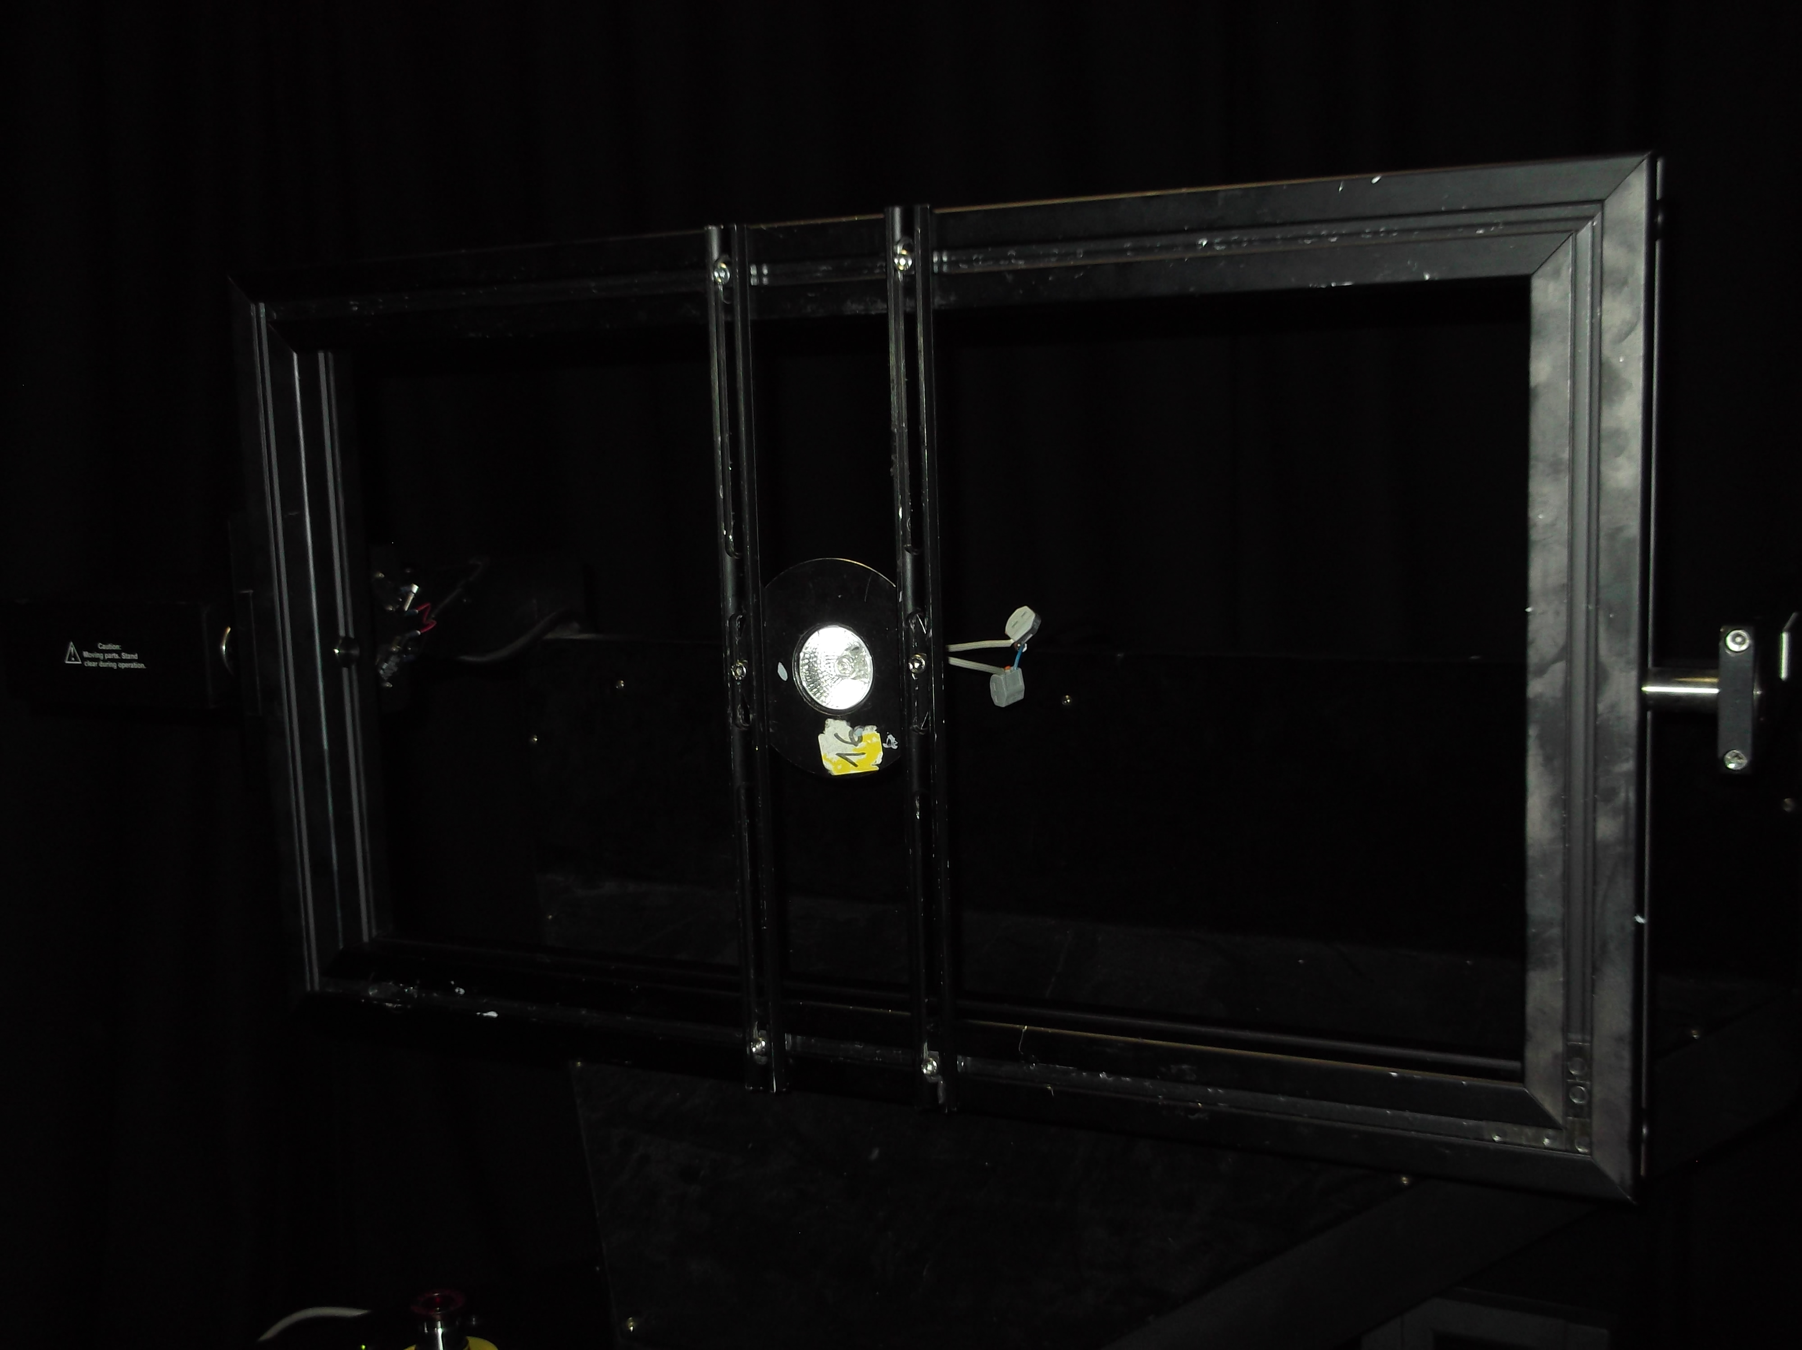

Signature:



_________________________________

Print Name:

D CHAMBERS

_________________________________

Date:

27/11/2013

________________________________

Test Engineer  
*Duly authorised to sign on behalf of:*

Photometric and Optical Testing Services LLP