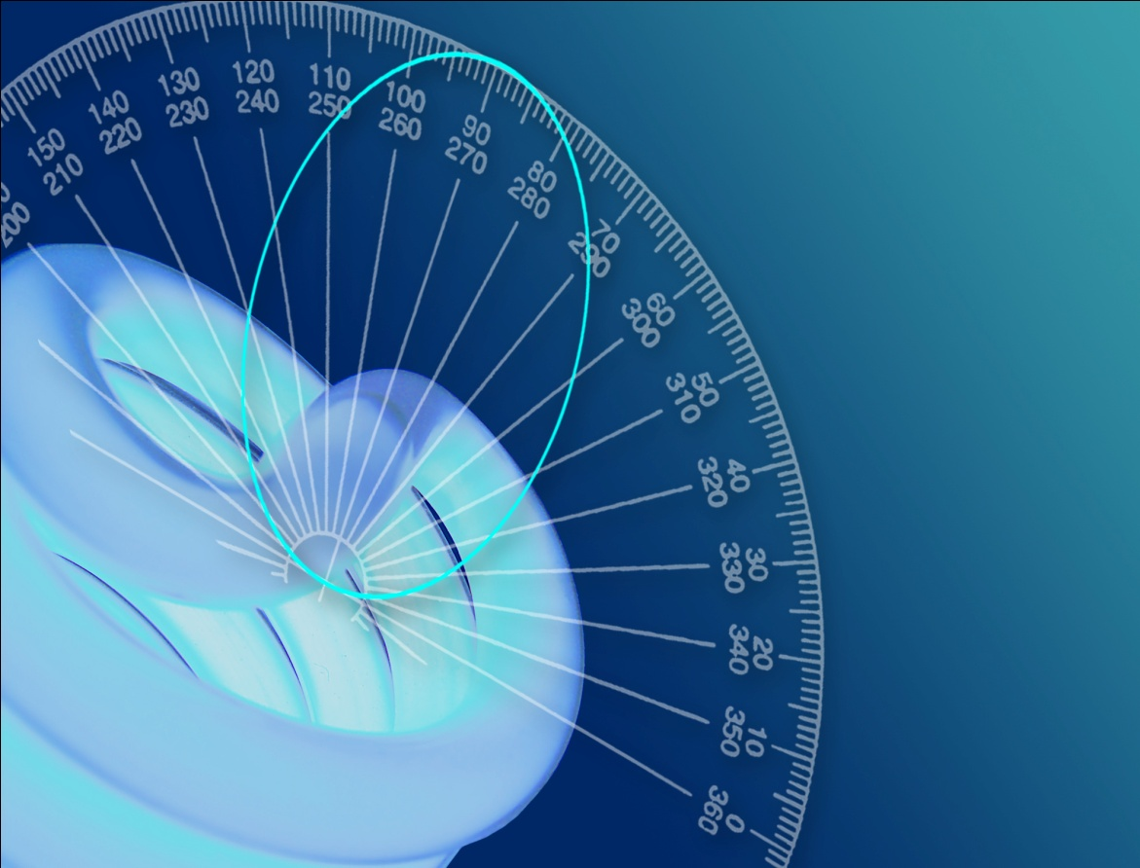

Photometric Test Report

Photometric and Optical Testing Services

Cotswold Business Centre

42 A P Ellis Road  
Rissington Business Park  
Upper Rissington  
Gloucestershire  
GL54 2QB  
UK

Tel: 01451 812 222

Fax: 01451 812 201

|  |  |  |
| --- | --- | --- |
| **POTS Photometric Test Report** | | |
| Report Number: POTS/12011_3 | Report Date: 03-02-2012 | Prepared By: G John |
| Test Laboratory: Photometric and Optical Testing Services, Cotswold Business Centre, 42 A P Ellis Road, Rissington Business Park, Upper Rissington, Gloucestershire, GL54 2QB | | |
| Company Registration Number: Registered in England & Wales No. OC352911 | | |
| Registered Address: Thistle Down Barn, Holcot Lane, Sywell, Northampton, NN6 0BG | | |

|  |  |
| --- | --- |
| **Client Details** | |
| Contact: Morris Robinson | Company: Far Eastern Manufacturing |
| Address: Major House, Unit B, 964 North Circular Road, London NW2 7JR | |
|  | Email: morris@traypoint.com |

|  |  |
| --- | --- |
| **Details of Product Tested** | |
| Manufacturer: LEDLite | Source Type: Fire rated dimmable downlight |
| Model: 50 degree wide warmer white | Serial Number: LTFD12WW |
| Description: LED downlight | |
| Lamp Type:LED | |
| Power Supply Used: Interruptible AC power supply | |
| Input voltage(V): 241.2 | Input Current (mA): 52 |
| Input power(W): 9.929 | Power factor: 0.7760 |
| Length of luminaire (mm):80 | Diameter of Luminaire (mm): 80 |

|  |  |
| --- | --- |
| **Results** | |
| Flux (lumens): 547.5 lumens |  |
| CIE 1931 Chromaticity Cx: 0.4472 | CIE 1931 Chromaticity Cy: 0.4211 |
| CRI (%): 59.90 | CCT (K): 2972 |

Figure 1: Spectral Irradiance

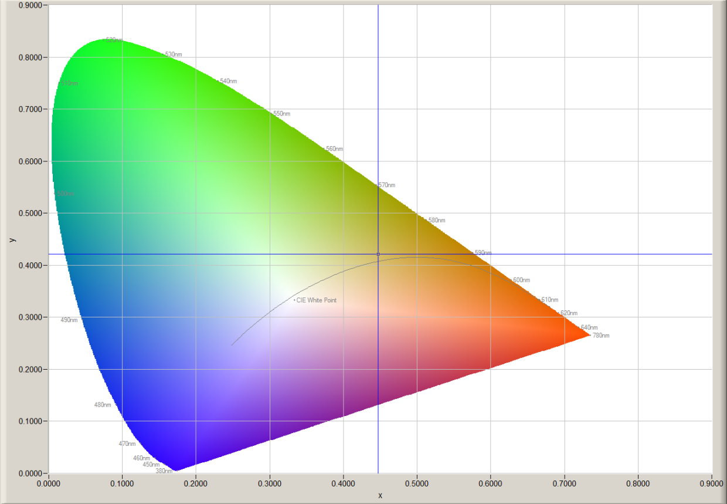

Figure 2: CIE 1931 2° Chromaticity Diagram

|  |  |  |  |
| --- | --- | --- | --- |
| **Goniophotometer Test** | | | |
| Date of Test: 31-01-2012 | | Ambient Temperature: 25°C | |
| Measurement Filename: 50 deg wide w warm | | | |
| Instrument Used: Radiant Imaging NFMS0800 Goniometer with ProMetric PM-1200N-1 Imaging Photometer | | | |
| Photometer Working Distance: 2m | | Measurement Geometry: Far-Field | |
| Comments: | | | |
| Reference Photometer Used: Specbos1201 | | Reference Photometer Serial Number: 2911670 | |
| Traceable: to NPL standards, UKAS Accredited | | Calibration Certificate Number: 121104 | |
| Calibration Certificate Date: 25th October 2011 | | Sample Stabilisation Time (minutes):60 | |
| Reference Photometer Calibration Uncertainty: ± 2.4% (*k=2*, 20-200 lux, CIE illuminant A source) | | | |
| **Scan Set Up** | | | |
| **Direction** | **Range** | | **Increment** |
| Inclination Zone 1 | 0-90° | | 3° |
| Azimuth | 0-360° | | 10° |
| **Results (after stabilisation)** |  | |  |
| Integrated Luminous Flux (lumens): 547.5 | Peak Intensity (1° Spot, candelas): 1378.1 | |  |
| Beam Angle (50% of max intensity C0-180, degrees): 35.0 | | | |
| Photometric Filename (IES LM-63-2002): 50 deg wide w warm | | | |
| IES File – Absolute or Relative Format? Absolute | | | |
| Photometric Filename (EULUMDAT): 50 deg wide w warm | | | |
| EULUMDAT File – Absolute or Relative Format? Absolute | | | |

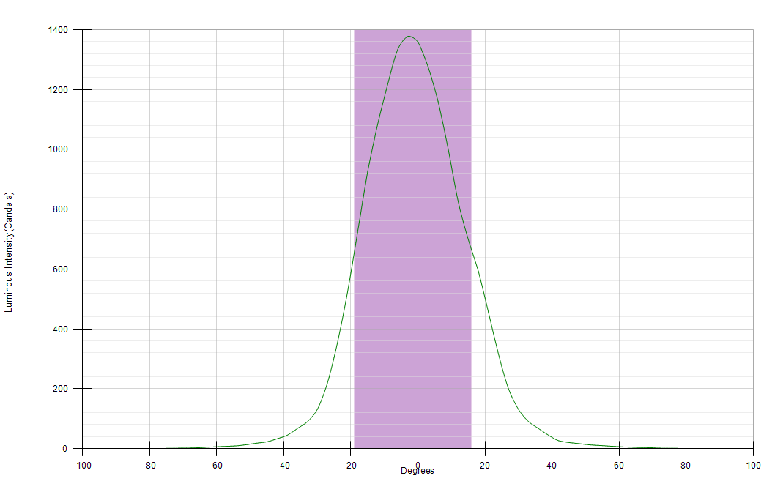

Figure 3: Far-Field Luminous Intensity (C0-180, Cartesian Coordinates)

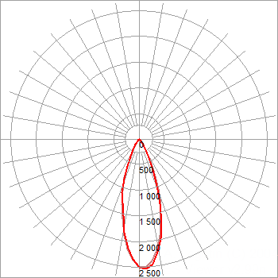

Figure 4: Far-Field Luminous Intensity (C0-180, C90-270, Polar Coordinates)

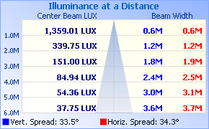

Figure 5. Illuminance cone diagram.

|  |  |  |  |  |  |  |  |  |  |  |  |  |  |  |  |  |  |  |  |  |  |  |  |  |  |  |  |  |  |  |  |  |  |  |  |  |
| --- | --- | --- | --- | --- | --- | --- | --- | --- | --- | --- | --- | --- | --- | --- | --- | --- | --- | --- | --- | --- | --- | --- | --- | --- | --- | --- | --- | --- | --- | --- | --- | --- | --- | --- | --- | --- |
|  | **0** | **10** | **20** | **30** | **40** | **50** | **60** | **70** | **80** | **90** | **100** | **110** | **120** | **130** | **140** | **150** | **160** | **170** | **180** | **190** | **200** | **210** | **220** | **230** | **240** | **250** | **260** | **270** | **280** | **290** | **300** | **310** | **320** | **330** | **340** | **350** |
| **0** | 1359.0 | 1359.0 | 1359.0 | 1359.0 | 1359.0 | 1359.0 | 1359.0 | 1359.0 | 1359.0 | 1359.0 | 1359.0 | 1359.0 | 1359.0 | 1359.0 | 1359.0 | 1359.0 | 1359.0 | 1359.0 | 1359.0 | 1359.0 | 1359.0 | 1359.0 | 1359.0 | 1359.0 | 1359.0 | 1359.0 | 1359.0 | 1359.0 | 1359.0 | 1359.0 | 1359.0 | 1359.0 | 1359.0 | 1359.0 | 1359.0 | 1359.0 |
| **3** | 1378.0 | 1388.5 | 1394.7 | 1394.9 | 1392.9 | 1389.5 | 1384.8 | 1378.4 | 1371.3 | 1364.0 | 1355.5 | 1345.1 | 1333.3 | 1320.6 | 1309.4 | 1305.8 | 1286.6 | 1283.1 | 1277.1 | 1269.8 | 1263.1 | 1271.1 | 1263.6 | 1265.7 | 1272.4 | 1277.2 | 1281.6 | 1288.8 | 1297.1 | 1307.4 | 1315.7 | 1325.0 | 1342.2 | 1356.4 | 1365.5 | 1370.4 |
| **6** | 1335.2 | 1343.2 | 1359.9 | 1365.3 | 1358.9 | 1349.8 | 1342.4 | 1327.3 | 1315.3 | 1301.4 | 1281.3 | 1265.6 | 1246.3 | 1225.5 | 1215.7 | 1205.1 | 1187.6 | 1166.0 | 1160.3 | 1148.0 | 1153.3 | 1148.4 | 1142.0 | 1139.6 | 1145.7 | 1153.2 | 1161.6 | 1173.8 | 1189.5 | 1209.6 | 1228.3 | 1240.7 | 1267.6 | 1289.5 | 1296.6 | 1317.2 |
| **9** | 1218.4 | 1229.9 | 1246.7 | 1244.1 | 1246.5 | 1240.8 | 1233.2 | 1220.6 | 1205.7 | 1186.2 | 1165.4 | 1143.7 | 1112.9 | 1086.6 | 1061.6 | 1038.3 | 1033.3 | 1007.1 | 1002.4 | 984.6 | 985.5 | 966.9 | 972.4 | 976.4 | 988.4 | 1001.1 | 1011.8 | 1032.0 | 1047.7 | 1070.1 | 1087.6 | 1110.6 | 1128.9 | 1148.3 | 1184.1 | 1194.3 |
| **12** | 1084.5 | 1089.5 | 1099.5 | 1109.8 | 1120.8 | 1110.4 | 1101.4 | 1078.5 | 1062.6 | 1043.0 | 1019.3 | 991.8 | 965.9 | 940.8 | 920.0 | 881.2 | 859.8 | 839.7 | 825.5 | 813.2 | 807.2 | 802.4 | 817.7 | 824.8 | 823.7 | 838.2 | 848.9 | 866.8 | 893.7 | 905.5 | 938.6 | 965.4 | 997.7 | 1008.7 | 1031.7 | 1059.5 |
| **15** | 924.9 | 929.9 | 951.4 | 956.6 | 956.9 | 962.0 | 943.9 | 931.1 | 904.6 | 890.3 | 860.2 | 835.9 | 797.1 | 774.7 | 748.4 | 722.9 | 710.4 | 694.9 | 699.1 | 685.2 | 689.1 | 685.0 | 684.3 | 692.1 | 695.8 | 702.4 | 699.9 | 718.7 | 727.9 | 755.1 | 771.7 | 797.6 | 831.3 | 846.2 | 858.2 | 892.6 |
| **18** | 722.4 | 745.2 | 743.3 | 764.4 | 759.6 | 771.2 | 749.9 | 742.1 | 740.2 | 725.5 | 710.4 | 691.8 | 658.5 | 638.7 | 633.0 | 611.0 | 597.9 | 591.6 | 592.8 | 591.1 | 575.8 | 578.5 | 567.0 | 571.4 | 563.1 | 566.0 | 580.3 | 576.5 | 610.2 | 596.5 | 607.0 | 628.2 | 631.1 | 663.6 | 668.4 | 713.3 |
| **21** | 522.5 | 544.7 | 550.6 | 559.0 | 571.3 | 572.5 | 575.3 | 586.7 | 576.3 | 565.3 | 553.9 | 549.5 | 519.3 | 501.4 | 495.7 | 480.0 | 465.5 | 453.1 | 456.4 | 446.1 | 443.2 | 440.6 | 434.4 | 415.6 | 414.9 | 422.8 | 425.0 | 438.8 | 436.4 | 447.7 | 459.7 | 469.7 | 481.7 | 507.0 | 496.8 | 532.9 |
| **24** | 353.4 | 365.9 | 375.0 | 376.2 | 405.3 | 402.5 | 414.4 | 413.4 | 407.9 | 400.3 | 386.8 | 379.1 | 356.1 | 344.0 | 334.9 | 314.1 | 320.0 | 307.6 | 316.3 | 307.8 | 310.3 | 288.9 | 286.0 | 272.4 | 275.3 | 279.8 | 285.5 | 282.6 | 300.6 | 306.6 | 299.1 | 310.5 | 307.9 | 314.4 | 333.5 | 344.7 |
| **27** | 218.7 | 228.3 | 225.8 | 239.1 | 260.4 | 253.3 | 252.7 | 259.0 | 250.9 | 254.8 | 254.9 | 248.0 | 236.1 | 236.0 | 211.4 | 199.2 | 192.0 | 193.8 | 199.8 | 192.6 | 195.6 | 187.2 | 176.7 | 168.1 | 180.0 | 173.1 | 166.5 | 174.1 | 174.9 | 177.7 | 174.0 | 180.6 | 197.1 | 205.7 | 214.6 | 212.9 |
| **30** | 130.7 | 134.3 | 141.2 | 155.6 | 151.1 | 151.5 | 161.8 | 160.0 | 154.7 | 154.9 | 159.4 | 151.4 | 131.4 | 140.0 | 122.2 | 124.5 | 120.1 | 125.4 | 130.5 | 126.0 | 122.4 | 126.5 | 120.2 | 115.9 | 120.1 | 117.3 | 115.3 | 112.4 | 120.1 | 119.1 | 118.3 | 122.4 | 124.9 | 127.2 | 125.9 | 139.5 |
| **33** | 89.3 | 91.4 | 95.9 | 101.8 | 98.2 | 103.8 | 103.7 | 101.3 | 104.2 | 106.4 | 103.0 | 100.5 | 93.1 | 90.6 | 92.1 | 90.6 | 90.0 | 91.4 | 89.8 | 91.6 | 89.4 | 91.8 | 89.2 | 83.0 | 81.9 | 83.4 | 80.3 | 81.9 | 82.0 | 84.0 | 84.1 | 84.3 | 84.5 | 89.6 | 89.5 | 89.1 |
| **36** | 66.6 | 66.1 | 67.9 | 73.4 | 72.9 | 73.3 | 73.4 | 74.7 | 73.7 | 73.1 | 71.8 | 71.7 | 73.2 | 67.6 | 66.5 | 66.7 | 64.3 | 64.2 | 66.5 | 65.1 | 62.8 | 66.9 | 64.6 | 60.6 | 60.3 | 58.9 | 57.6 | 59.4 | 59.1 | 58.2 | 61.3 | 61.0 | 62.4 | 64.0 | 65.7 | 63.9 |
| **39** | 44.4 | 44.6 | 46.2 | 47.6 | 48.8 | 51.4 | 51.8 | 51.4 | 50.3 | 49.2 | 50.1 | 51.8 | 49.5 | 46.4 | 44.5 | 42.7 | 42.0 | 40.2 | 44.2 | 43.0 | 42.1 | 39.8 | 43.9 | 41.5 | 40.3 | 39.5 | 38.7 | 39.8 | 41.1 | 40.8 | 40.9 | 41.1 | 41.8 | 42.8 | 43.8 | 41.9 |
| **42** | 32.7 | 30.1 | 32.2 | 32.7 | 32.8 | 34.9 | 34.9 | 33.1 | 33.6 | 32.9 | 33.7 | 33.4 | 32.2 | 28.5 | 28.3 | 25.7 | 25.3 | 24.0 | 26.1 | 27.5 | 26.3 | 25.6 | 29.5 | 26.9 | 26.3 | 25.5 | 26.0 | 25.5 | 26.7 | 28.4 | 28.1 | 28.1 | 28.5 | 29.2 | 32.8 | 29.6 |
| **45** | 22.6 | 22.5 | 22.3 | 23.9 | 24.0 | 23.4 | 23.9 | 23.7 | 24.5 | 25.6 | 24.0 | 22.8 | 22.3 | 20.5 | 18.7 | 18.3 | 18.9 | 18.4 | 20.2 | 20.2 | 18.8 | 19.3 | 17.7 | 19.4 | 19.1 | 18.9 | 19.8 | 19.2 | 20.9 | 18.8 | 20.5 | 18.7 | 19.6 | 22.2 | 21.3 | 21.2 |
| **48** | 18.1 | 15.7 | 17.3 | 18.6 | 17.3 | 17.5 | 17.6 | 19.0 | 19.2 | 20.3 | 19.1 | 17.4 | 17.5 | 15.7 | 16.0 | 15.4 | 16.7 | 15.1 | 16.4 | 15.9 | 15.2 | 15.9 | 14.3 | 14.4 | 13.9 | 15.6 | 14.9 | 15.7 | 15.3 | 14.8 | 15.9 | 14.6 | 15.5 | 15.9 | 17.7 | 15.2 |
| **51** | 13.3 | 11.5 | 12.5 | 14.4 | 13.8 | 13.3 | 14.0 | 14.9 | 14.7 | 15.2 | 14.1 | 12.7 | 13.4 | 12.3 | 11.7 | 12.3 | 13.9 | 12.3 | 12.6 | 12.5 | 11.5 | 13.4 | 11.1 | 11.0 | 11.6 | 13.3 | 12.2 | 12.1 | 11.9 | 11.0 | 13.0 | 11.7 | 11.4 | 12.5 | 14.4 | 11.2 |
| **54** | 9.2 | 9.3 | 9.6 | 10.2 | 8.9 | 9.9 | 10.5 | 10.9 | 12.2 | 9.9 | 11.0 | 9.7 | 10.6 | 9.0 | 8.6 | 8.8 | 9.7 | 8.5 | 10.5 | 9.5 | 9.1 | 8.1 | 7.9 | 8.2 | 7.9 | 9.0 | 7.8 | 9.3 | 8.3 | 9.4 | 8.0 | 8.4 | 8.6 | 9.2 | 9.2 | 8.7 |
| **57** | 7.6 | 7.5 | 6.7 | 6.3 | 6.6 | 7.0 | 7.0 | 7.7 | 8.3 | 8.1 | 8.5 | 7.1 | 6.5 | 6.4 | 6.6 | 6.2 | 6.5 | 6.7 | 8.3 | 7.3 | 6.8 | 6.1 | 5.9 | 5.9 | 5.8 | 6.4 | 6.1 | 7.0 | 6.4 | 6.4 | 5.5 | 5.9 | 6.1 | 6.2 | 6.2 | 6.6 |
| **60** | 6.0 | 4.6 | 4.8 | 5.3 | 4.9 | 5.2 | 5.4 | 5.4 | 6.4 | 6.1 | 5.6 | 5.1 | 4.7 | 4.6 | 5.1 | 4.5 | 5.0 | 4.8 | 6.2 | 5.1 | 4.5 | 4.6 | 4.3 | 4.2 | 4.1 | 4.2 | 4.6 | 4.7 | 4.9 | 4.4 | 3.9 | 4.5 | 4.4 | 4.1 | 4.5 | 4.7 |
| **63** | 4.4 | 3.1 | 3.1 | 3.2 | 3.2 | 3.6 | 3.6 | 3.8 | 4.2 | 4.5 | 4.2 | 3.6 | 3.2 | 3.2 | 3.5 | 3.1 | 3.3 | 3.3 | 4.8 | 3.7 | 3.3 | 3.0 | 3.0 | 3.0 | 2.8 | 3.0 | 3.3 | 3.5 | 3.6 | 2.9 | 2.6 | 3.0 | 2.8 | 2.8 | 2.7 | 2.9 |
| **66** | 2.6 | 2.2 | 1.8 | 2.1 | 2.2 | 2.6 | 2.5 | 2.7 | 3.4 | 4.0 | 2.9 | 2.1 | 2.2 | 2.5 | 2.2 | 2.2 | 2.0 | 2.5 | 3.6 | 2.8 | 2.0 | 1.9 | 2.1 | 2.1 | 1.9 | 2.0 | 2.4 | 2.6 | 2.8 | 2.0 | 1.8 | 2.0 | 2.1 | 1.9 | 1.9 | 2.1 |
| **69** | 1.7 | 1.2 | 1.0 | 1.2 | 1.4 | 1.6 | 1.5 | 1.6 | 2.3 | 3.2 | 2.1 | 1.4 | 1.5 | 1.6 | 1.4 | 1.3 | 1.3 | 1.8 | 3.0 | 2.0 | 1.3 | 1.2 | 1.4 | 1.4 | 1.3 | 1.4 | 1.9 | 1.8 | 2.1 | 1.3 | 1.1 | 1.2 | 1.3 | 1.0 | 1.1 | 1.5 |
| **72** | 1.2 | 0.6 | 0.4 | 0.6 | 0.9 | 1.0 | 0.9 | 0.7 | 1.5 | 2.9 | 1.4 | 0.8 | 0.9 | 1.0 | 1.0 | 0.9 | 0.7 | 1.2 | 1.4 | 0.9 | 0.7 | 0.7 | 0.8 | 0.8 | 0.7 | 0.7 | 1.1 | 2.5 | 1.3 | 0.5 | 0.7 | 0.8 | 0.7 | 0.5 | 0.4 | 0.7 |
| **75** | 0.7 | 0.3 | 0.1 | 0.2 | 0.4 | 0.6 | 0.4 | 0.3 | 0.9 | 2.3 | 0.7 | 0.3 | 0.4 | 0.5 | 0.5 | 0.4 | 0.3 | 0.5 | 1.1 | 0.4 | 0.2 | 0.2 | 0.3 | 0.4 | 0.3 | 0.2 | 0.5 | 1.8 | 0.7 | 0.2 | 0.3 | 0.5 | 0.3 | 0.2 | 0.2 | 0.1 |
| **78** | 0.2 | 0.1 | 0.0 | 0.0 | 0.1 | 0.1 | 0.1 | 0.0 | 0.4 | 1.5 | 0.2 | 0.0 | 0.1 | 0.2 | 0.1 | 0.1 | 0.1 | 0.1 | 0.6 | 0.1 | 0.0 | 0.0 | 0.1 | 0.1 | 0.1 | 0.0 | 0.1 | 1.1 | 0.2 | 0.0 | 0.1 | 0.1 | 0.1 | 0.1 | 0.0 | 0.0 |
| **81** | 0.0 | 0.0 | 0.0 | 0.0 | 0.0 | 0.0 | 0.0 | 0.0 | 0.0 | 0.7 | 0.0 | 0.0 | 0.0 | 0.0 | 0.0 | 0.0 | 0.0 | 0.0 | 0.0 | 0.0 | 0.0 | 0.0 | 0.0 | 0.0 | 0.0 | 0.0 | 0.0 | 0.0 | 0.0 | 0.0 | 0.0 | 0.0 | 0.0 | 0.0 | 0.0 | 0.0 |
| **84** | 0.0 | 0.0 | 0.0 | 0.0 | 0.0 | 0.0 | 0.0 | 0.0 | 0.0 | 0.0 | 0.0 | 0.0 | 0.0 | 0.0 | 0.0 | 0.0 | 0.0 | 0.0 | 0.0 | 0.0 | 0.0 | 0.0 | 0.0 | 0.0 | 0.0 | 0.0 | 0.0 | 0.0 | 0.0 | 0.0 | 0.0 | 0.0 | 0.0 | 0.0 | 0.0 | 0.0 |
| **87** | 0.0 | 0.0 | 0.0 | 0.0 | 0.0 | 0.0 | 0.0 | 0.0 | 0.0 | 0.0 | 0.0 | 0.0 | 0.0 | 0.0 | 0.0 | 0.0 | 0.0 | 0.0 | 0.0 | 0.0 | 0.0 | 0.0 | 0.0 | 0.0 | 0.0 | 0.0 | 0.0 | 0.0 | 0.0 | 0.0 | 0.0 | 0.0 | 0.0 | 0.0 | 0.0 | 0.0 |
| **90** | 0.0 | 0.0 | 0.0 | 0.0 | 0.0 | 0.0 | 0.0 | 0.0 | 0.0 | 0.0 | 0.0 | 0.0 | 0.0 | 0.0 | 0.0 | 0.0 | 0.0 | 0.0 | 0.0 | 0.0 | 0.0 | 0.0 | 0.0 | 0.0 | 0.0 | 0.0 | 0.0 | 0.0 | 0.0 | 0.0 | 0.0 | 0.0 | 0.0 | 0.0 | 0.0 | 0.0 |

Table 1. Luminous intensity values

Signature:

_________________________________

Print Name:

GH JOHN

_________________________________

Date:

03-02-2012

_________________________________

Partner / Director  
*Duly authorised to sign on behalf of:*

Photometric and Optical Testing Services LLP