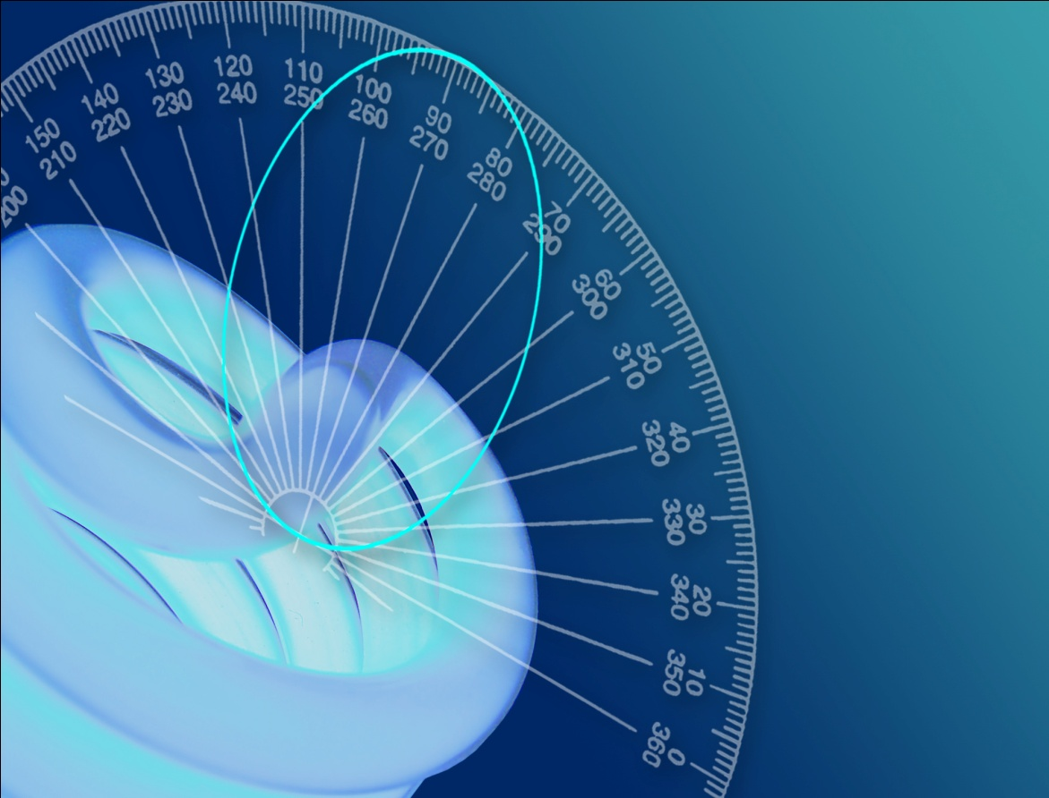

Photometric Test Report

Photometric and Optical Testing Services

Cotswold Business Centre

42 A P Ellis Road  
Rissington Business Park  
Upper Rissington  
Gloucestershire  
GL54 2QB  
UK

Tel: 01451 812 222

Fax: 01451 812 201

|  |  |  |
| --- | --- | --- |
| **POTS Photometric Test Report** | | |
| Report Number: POTS/12011_1 | Report Date: 02-02-2012 | Prepared By: G John |
| Test Laboratory: Photometric and Optical Testing Services, Cotswold Business Centre, 42 A P Ellis Road, Rissington Business Park, Upper Rissington, Gloucestershire, GL54 2QB | | |
| Company Registration Number: Registered in England & Wales No. OC352911 | | |
| Registered Address: Thistle Down Barn, Holcot Lane, Sywell, Northampton, NN6 0BG | | |

|  |  |
| --- | --- |
| **Client Details** | |
| Contact: Morris Robinson | Company: Far Eastern Manufacturing |
| Address: Major House, Unit B, 964 North Circular Road, London NW2 7JR | |
|  | Email: morris@traypoint.com |

|  |  |
| --- | --- |
| **Details of Product Tested** | |
| Manufacturer: LEDLite | Source Type: Fire rated dimmable downlight |
| Model: 50 degree wide daylight | Serial Number: LTFD12DL |
| Description: LED downlight | |
| Lamp Type:LED | |
| Power Supply Used: Interruptible AC power supply | |
| Input voltage(V): 242.4 | Input Current (mA): 54 |
| Input power(W): 10.14 | Power factor: 0.772222 |
| Length of luminaire (mm):80 | Diameter of Luminaire (mm): 80 |

|  |  |
| --- | --- |
| **Results** | |
| Flux (lumens): 628.8 lumens |  |
| CIE 1931 Chromaticity Cx: | CIE 1931 Chromaticity Cy: |
| CRI (%): | CCT (K): |

Figure 1: Spectral Irradiance

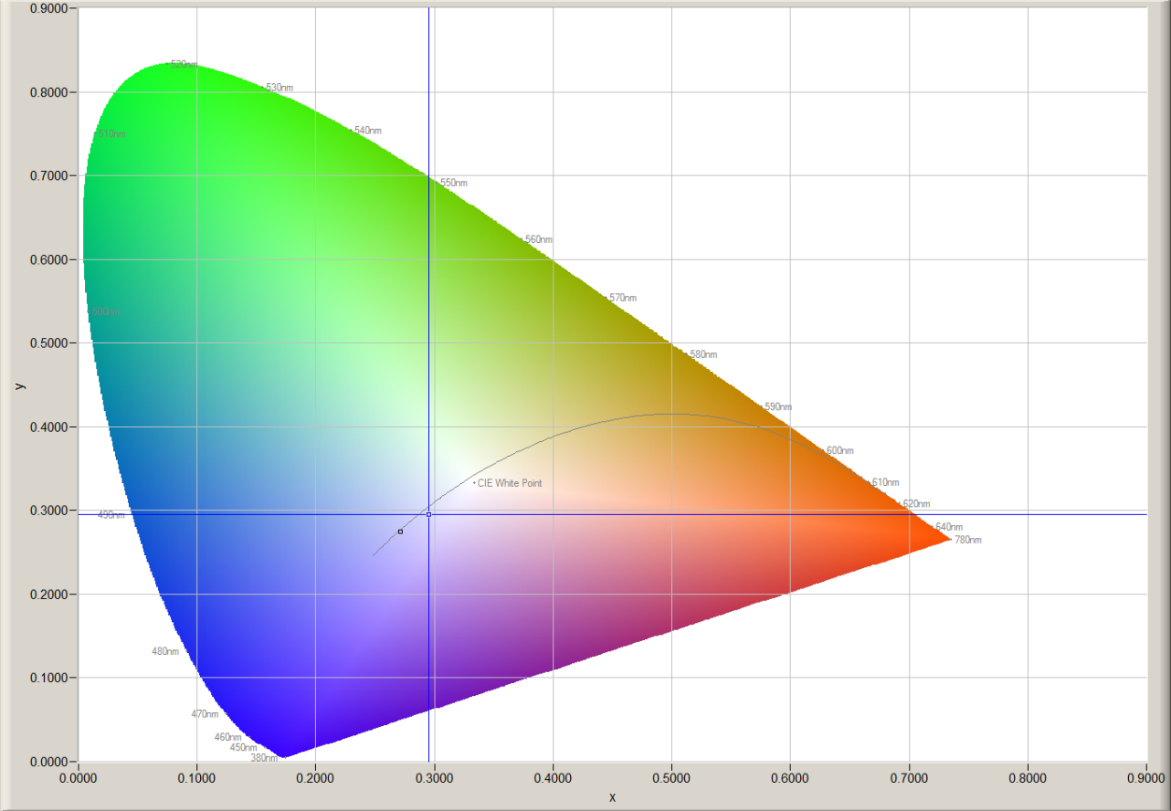

Figure 2: CIE 1931 2° Chromaticity Diagram

|  |  |  |  |
| --- | --- | --- | --- |
| **Goniophotometer Test** | | | |
| Date of Test: 27-01-2012 | | Ambient Temperature: 25°C | |
| Measurement Filename: 50 deg wide daylight | | | |
| Instrument Used: Radiant Imaging NFMS0800 Goniometer with ProMetric PM-1200N-1 Imaging Photometer | | | |
| Photometer Working Distance: 2m | | Measurement Geometry: Far-Field | |
| Comments: | | | |
| Reference Photometer Used: Specbos1201 | | Reference Photometer Serial Number: 2911670 | |
| Traceable: to NPL standards, UKAS Accredited | | Calibration Certificate Number: 121104 | |
| Calibration Certificate Date: 25th October 2011 | | Sample Stabilisation Time (minutes):60 | |
| Reference Photometer Calibration Uncertainty: ± 2.4% (*k=2*, 20-200 lux, CIE illuminant A source) | | | |
| **Scan Set Up** | | | |
| **Direction** | **Range** | | **Increment** |
| Inclination Zone 1 | 0-90° | | 3° |
| Azimuth | 0-360° | | 10° |
| **Results (after stabilisation)** |  | |  |
| Integrated Luminous Flux (lumens): 628.8 | Peak Intensity (1° Spot, candelas): 1602.0 | |  |
| Beam Angle (50% of max intensity C0-180, degrees): 36.0 | | | |
| Photometric Filename (IES LM-63-2002): 50 deg wide daylight | | | |
| IES File – Absolute or Relative Format? Absolute | | | |
| Photometric Filename (EULUMDAT): 50 deg wide daylight | | | |
| EULUMDAT File – Absolute or Relative Format? Absolute | | | |

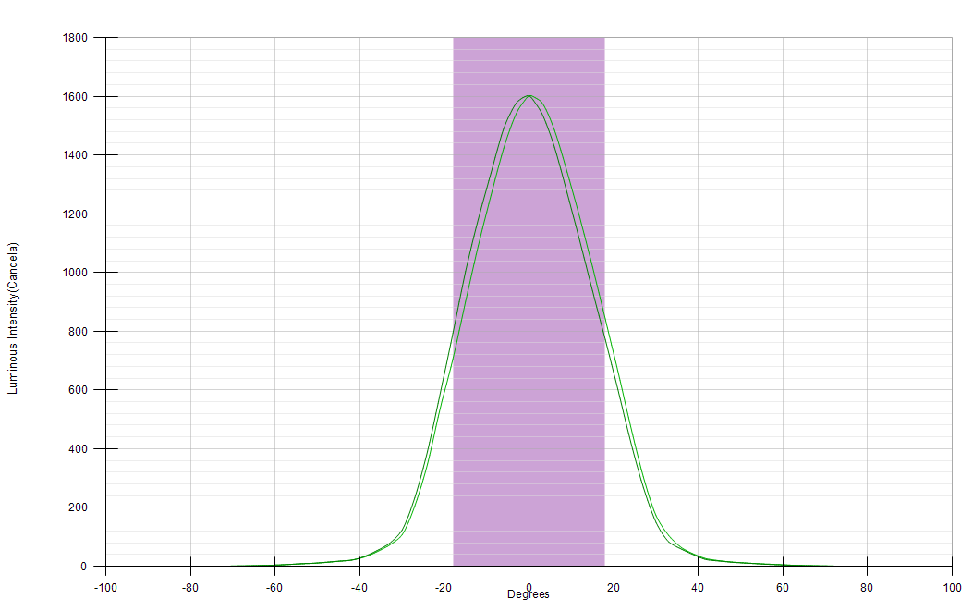

Figure 3: Far-Field Luminous Intensity (C0-180, Cartesian Coordinates)

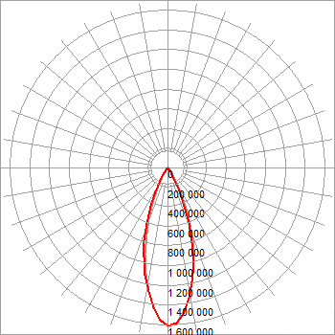

Figure 4: Far-Field Luminous Intensity (C0-180, C90-270, Polar Coordinates)

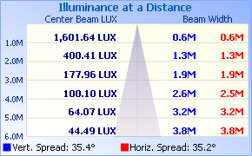

Figure 5. Illuminance cone diagram.

|  |  |  |  |  |  |  |  |  |  |  |  |  |  |  |  |  |  |  |  |  |  |  |  |  |  |  |  |  |  |  |  |  |  |  |  |  |
| --- | --- | --- | --- | --- | --- | --- | --- | --- | --- | --- | --- | --- | --- | --- | --- | --- | --- | --- | --- | --- | --- | --- | --- | --- | --- | --- | --- | --- | --- | --- | --- | --- | --- | --- | --- | --- |
|  | **0** | **10** | **20** | **30** | **40** | **50** | **60** | **70** | **80** | **90** | **100** | **110** | **120** | **130** | **140** | **150** | **160** | **170** | **180** | **190** | **200** | **210** | **220** | **230** | **240** | **250** | **260** | **270** | **280** | **290** | **300** | **310** | **320** | **330** | **340** | **350** |
| **0** | 1601.6 | 1601.6 | 1601.6 | 1601.6 | 1601.6 | 1601.6 | 1601.6 | 1601.6 | 1601.6 | 1601.6 | 1601.6 | 1601.6 | 1601.6 | 1601.6 | 1601.6 | 1601.6 | 1601.6 | 1601.6 | 1601.6 | 1601.6 | 1601.6 | 1601.6 | 1601.6 | 1601.6 | 1601.6 | 1601.6 | 1601.6 | 1601.6 | 1601.6 | 1601.6 | 1601.6 | 1601.6 | 1601.6 | 1601.6 | 1601.6 | 1601.6 |
| **3** | 1577.6 | 1583.2 | 1585.8 | 1589.8 | 1585.8 | 1583.9 | 1582.9 | 1581.6 | 1580.2 | 1579.4 | 1576.4 | 1573.5 | 1569.7 | 1564.9 | 1560.7 | 1560.7 | 1547.3 | 1546.5 | 1542.7 | 1536.8 | 1531.9 | 1540.6 | 1534.6 | 1535.3 | 1538.5 | 1540.1 | 1541.0 | 1542.3 | 1543.5 | 1547.6 | 1549.9 | 1551.5 | 1560.2 | 1570.7 | 1571.0 | 1574.1 |
| **6** | 1489.9 | 1488.8 | 1501.0 | 1503.2 | 1499.1 | 1495.1 | 1497.8 | 1492.3 | 1489.2 | 1484.9 | 1476.1 | 1472.2 | 1466.0 | 1456.8 | 1457.0 | 1456.3 | 1448.0 | 1430.0 | 1427.2 | 1417.5 | 1425.2 | 1422.4 | 1415.7 | 1412.3 | 1416.5 | 1417.8 | 1419.2 | 1423.3 | 1426.7 | 1435.1 | 1442.0 | 1444.1 | 1461.6 | 1476.0 | 1476.6 | 1476.7 |
| **9** | 1339.1 | 1332.0 | 1344.2 | 1336.1 | 1342.3 | 1346.9 | 1352.8 | 1353.4 | 1349.4 | 1341.9 | 1335.8 | 1327.9 | 1315.6 | 1306.1 | 1296.4 | 1286.0 | 1290.5 | 1271.6 | 1270.6 | 1256.4 | 1259.4 | 1243.2 | 1244.1 | 1244.7 | 1249.6 | 1255.6 | 1258.0 | 1262.9 | 1267.0 | 1275.3 | 1282.6 | 1291.6 | 1300.3 | 1307.4 | 1328.2 | 1325.2 |
| **12** | 1181.8 | 1170.0 | 1172.4 | 1178.4 | 1196.9 | 1196.4 | 1201.2 | 1191.5 | 1189.7 | 1186.4 | 1178.1 | 1168.3 | 1159.2 | 1154.2 | 1151.1 | 1128.1 | 1118.4 | 1107.3 | 1107.0 | 1095.2 | 1088.0 | 1085.7 | 1095.6 | 1092.4 | 1086.7 | 1086.7 | 1088.3 | 1091.7 | 1099.8 | 1100.8 | 1116.6 | 1128.5 | 1146.6 | 1146.0 | 1149.9 | 1164.3 |
| **15** | 1004.5 | 996.9 | 1010.7 | 1013.3 | 1020.4 | 1032.8 | 1027.1 | 1029.9 | 1018.3 | 1018.9 | 1007.7 | 1002.2 | 981.5 | 973.1 | 966.8 | 953.0 | 945.0 | 929.7 | 937.1 | 919.0 | 924.5 | 915.4 | 910.4 | 912.7 | 908.5 | 902.6 | 890.2 | 901.8 | 898.2 | 918.1 | 922.3 | 939.4 | 959.7 | 966.3 | 964.3 | 991.8 |
| **18** | 793.1 | 808.5 | 804.5 | 827.3 | 827.2 | 845.3 | 831.5 | 834.8 | 847.2 | 842.3 | 838.8 | 831.1 | 806.7 | 798.2 | 804.9 | 787.2 | 772.0 | 774.9 | 772.0 | 768.0 | 753.3 | 750.8 | 728.5 | 733.1 | 711.0 | 710.8 | 715.4 | 705.8 | 734.2 | 712.9 | 713.9 | 730.3 | 730.1 | 758.2 | 755.8 | 798.0 |
| **21** | 589.0 | 610.5 | 615.6 | 623.8 | 638.0 | 643.2 | 653.2 | 668.7 | 667.3 | 663.4 | 660.4 | 665.4 | 637.2 | 628.5 | 630.3 | 618.2 | 604.8 | 594.1 | 601.3 | 589.9 | 587.8 | 581.8 | 570.0 | 543.8 | 535.5 | 536.4 | 531.0 | 538.0 | 526.9 | 536.1 | 543.4 | 551.8 | 562.2 | 584.6 | 569.6 | 601.3 |
| **24** | 391.6 | 402.3 | 418.5 | 423.1 | 456.7 | 457.8 | 474.7 | 479.5 | 478.2 | 476.6 | 468.0 | 467.9 | 453.0 | 442.4 | 437.9 | 414.6 | 426.0 | 411.7 | 424.3 | 413.4 | 416.4 | 387.2 | 381.8 | 360.9 | 358.0 | 359.2 | 358.3 | 348.2 | 361.6 | 365.6 | 353.8 | 365.4 | 358.9 | 361.3 | 380.4 | 390.0 |
| **27** | 233.9 | 241.8 | 247.2 | 265.3 | 290.1 | 286.2 | 289.9 | 298.6 | 297.7 | 304.6 | 307.0 | 306.0 | 299.7 | 305.4 | 275.4 | 264.1 | 259.0 | 268.7 | 268.9 | 260.7 | 255.9 | 245.6 | 231.5 | 219.0 | 226.4 | 215.5 | 205.1 | 205.6 | 204.1 | 205.1 | 204.0 | 209.6 | 225.3 | 230.6 | 238.4 | 237.5 |
| **30** | 123.5 | 126.1 | 135.5 | 158.0 | 155.1 | 158.4 | 174.2 | 174.0 | 171.6 | 172.5 | 180.8 | 176.9 | 155.7 | 166.4 | 142.7 | 146.0 | 137.8 | 145.5 | 149.5 | 139.5 | 129.6 | 140.2 | 128.9 | 121.9 | 129.6 | 122.2 | 115.6 | 107.1 | 121.2 | 118.4 | 116.6 | 124.9 | 126.1 | 125.9 | 122.3 | 138.0 |
| **33** | 77.7 | 79.0 | 80.4 | 90.6 | 90.0 | 99.6 | 98.7 | 96.2 | 97.1 | 104.7 | 101.1 | 96.3 | 87.6 | 88.7 | 85.8 | 86.0 | 83.4 | 84.0 | 83.0 | 85.7 | 80.0 | 85.9 | 81.2 | 74.2 | 73.3 | 75.5 | 69.1 | 71.9 | 71.5 | 74.5 | 73.9 | 72.7 | 74.9 | 81.2 | 79.6 | 76.5 |
| **36** | 52.8 | 53.7 | 55.7 | 61.0 | 61.1 | 62.4 | 63.2 | 64.3 | 63.9 | 63.6 | 62.6 | 63.2 | 65.6 | 58.1 | 58.4 | 59.0 | 55.2 | 56.1 | 58.4 | 55.6 | 53.5 | 56.7 | 54.2 | 50.7 | 49.1 | 49.0 | 47.5 | 49.1 | 47.9 | 47.3 | 50.0 | 50.1 | 51.1 | 52.0 | 53.8 | 52.3 |
| **39** | 33.1 | 33.6 | 35.7 | 36.5 | 38.2 | 40.9 | 41.0 | 41.6 | 41.2 | 41.1 | 41.4 | 43.6 | 42.4 | 39.3 | 37.8 | 36.5 | 37.1 | 35.6 | 38.4 | 36.4 | 35.6 | 33.8 | 36.2 | 34.2 | 32.9 | 32.9 | 32.4 | 30.9 | 32.8 | 32.4 | 31.8 | 32.4 | 31.1 | 32.7 | 33.7 | 31.5 |
| **42** | 20.7 | 20.6 | 22.8 | 21.9 | 23.2 | 26.2 | 25.8 | 25.8 | 25.7 | 25.3 | 27.5 | 26.8 | 26.7 | 23.9 | 23.4 | 22.6 | 22.5 | 22.7 | 22.3 | 23.6 | 22.8 | 22.0 | 24.8 | 22.9 | 22.6 | 22.3 | 22.1 | 21.1 | 20.9 | 22.2 | 22.0 | 21.7 | 21.7 | 22.1 | 24.9 | 22.2 |
| **45** | 17.3 | 16.8 | 16.0 | 17.0 | 16.8 | 17.3 | 17.8 | 17.4 | 19.3 | 18.9 | 18.5 | 17.7 | 17.4 | 17.1 | 16.2 | 16.6 | 16.6 | 16.6 | 17.7 | 17.1 | 16.6 | 16.1 | 16.1 | 17.4 | 16.9 | 16.6 | 16.9 | 17.0 | 16.5 | 16.1 | 16.6 | 16.1 | 17.1 | 17.6 | 17.7 | 16.9 |
| **48** | 13.9 | 14.9 | 14.3 | 13.6 | 14.1 | 13.9 | 15.3 | 15.0 | 14.6 | 14.4 | 14.5 | 14.3 | 13.8 | 13.9 | 14.5 | 13.8 | 13.7 | 13.4 | 13.7 | 13.9 | 14.1 | 13.7 | 13.7 | 13.8 | 13.6 | 13.0 | 13.3 | 13.0 | 13.3 | 13.7 | 13.0 | 13.5 | 14.2 | 15.0 | 14.0 | 14.4 |
| **51** | 10.5 | 12.2 | 11.2 | 10.8 | 11.1 | 11.3 | 12.4 | 11.7 | 11.6 | 11.6 | 11.6 | 11.2 | 11.0 | 11.3 | 11.4 | 11.5 | 10.7 | 10.9 | 11.0 | 11.6 | 11.5 | 11.2 | 11.1 | 11.3 | 11.1 | 9.9 | 10.5 | 10.1 | 10.6 | 11.0 | 10.2 | 10.4 | 11.2 | 12.1 | 10.4 | 10.9 |
| **54** | 8.9 | 9.0 | 8.3 | 7.7 | 8.0 | 9.1 | 9.2 | 9.5 | 9.0 | 9.1 | 9.3 | 9.7 | 8.3 | 8.5 | 9.0 | 8.6 | 8.4 | 8.6 | 8.5 | 9.0 | 9.0 | 8.2 | 8.6 | 8.3 | 8.9 | 8.3 | 8.6 | 8.0 | 8.0 | 8.0 | 7.3 | 8.0 | 8.3 | 8.1 | 8.4 | 8.0 |
| **57** | 6.1 | 5.9 | 5.7 | 5.6 | 6.0 | 6.4 | 6.3 | 6.9 | 7.1 | 7.1 | 6.8 | 6.6 | 6.1 | 6.1 | 6.2 | 6.2 | 6.5 | 6.8 | 6.2 | 6.5 | 6.4 | 6.2 | 6.5 | 6.1 | 6.3 | 6.5 | 6.5 | 5.9 | 5.4 | 5.4 | 5.3 | 5.6 | 5.8 | 5.7 | 6.0 | 6.3 |
| **60** | 4.0 | 4.0 | 4.1 | 4.2 | 4.4 | 4.4 | 4.8 | 5.0 | 5.6 | 5.1 | 5.0 | 4.5 | 4.4 | 4.3 | 5.0 | 4.7 | 4.8 | 4.9 | 4.6 | 4.3 | 4.6 | 4.5 | 4.7 | 4.3 | 4.4 | 4.4 | 4.6 | 4.0 | 3.9 | 3.8 | 3.5 | 3.9 | 4.2 | 4.5 | 4.0 | 4.2 |
| **63** | 2.5 | 2.5 | 2.7 | 2.7 | 2.8 | 2.8 | 3.2 | 3.5 | 3.9 | 3.3 | 3.4 | 3.1 | 3.1 | 2.9 | 3.3 | 3.2 | 3.4 | 3.5 | 2.9 | 2.9 | 3.3 | 3.2 | 3.2 | 2.9 | 3.0 | 3.0 | 3.3 | 2.7 | 2.4 | 2.4 | 2.3 | 2.4 | 2.5 | 2.7 | 2.7 | 2.8 |
| **66** | 1.6 | 1.5 | 1.7 | 1.7 | 1.8 | 2.0 | 2.2 | 2.8 | 2.6 | 2.2 | 2.0 | 2.0 | 2.0 | 2.3 | 2.0 | 2.2 | 2.3 | 2.4 | 2.0 | 2.1 | 2.0 | 2.1 | 2.3 | 1.9 | 2.0 | 2.2 | 2.2 | 1.9 | 1.6 | 1.5 | 1.5 | 1.6 | 1.6 | 1.6 | 1.7 | 1.7 |
| **69** | 0.8 | 0.8 | 0.9 | 1.0 | 1.1 | 1.1 | 1.3 | 1.8 | 1.8 | 1.5 | 1.2 | 1.3 | 1.4 | 1.5 | 1.2 | 1.4 | 1.7 | 1.7 | 1.2 | 1.2 | 1.3 | 1.3 | 1.5 | 1.2 | 1.3 | 1.5 | 1.5 | 1.2 | 0.9 | 0.9 | 0.9 | 0.9 | 0.9 | 0.9 | 1.0 | 0.9 |
| **72** | 0.4 | 0.3 | 0.4 | 0.7 | 0.6 | 0.6 | 0.7 | 1.2 | 1.3 | 0.8 | 0.7 | 0.8 | 0.8 | 0.8 | 0.7 | 0.8 | 1.3 | 0.9 | 0.6 | 0.5 | 0.7 | 1.1 | 0.8 | 0.6 | 0.7 | 1.1 | 1.2 | 0.6 | 0.5 | 0.5 | 0.6 | 0.5 | 0.5 | 0.4 | 0.5 | 0.5 |
| **75** | 0.0 | 0.0 | 0.1 | 0.1 | 0.2 | 0.2 | 0.2 | 0.8 | 0.8 | 0.3 | 0.3 | 0.3 | 0.4 | 0.4 | 0.3 | 0.3 | 0.8 | 0.5 | 0.2 | 0.1 | 0.3 | 0.4 | 0.4 | 0.3 | 0.2 | 0.7 | 0.8 | 0.2 | 0.2 | 0.2 | 0.2 | 0.1 | 0.1 | 0.1 | 0.3 | 0.2 |
| **78** | 0.0 | 0.0 | 0.0 | 0.0 | 0.0 | 0.0 | 0.0 | 0.3 | 0.3 | 0.0 | 0.0 | 0.1 | 0.1 | 0.1 | 0.0 | 0.0 | 0.1 | 0.3 | 0.0 | 0.0 | 0.0 | 0.1 | 0.0 | 0.1 | 0.0 | 0.4 | 0.3 | 0.0 | 0.0 | 0.0 | 0.0 | 0.0 | 0.0 | 0.0 | 0.1 | 0.1 |
| **81** | 0.0 | 0.0 | 0.0 | 0.0 | 0.0 | 0.0 | 0.0 | 0.0 | 0.0 | 0.0 | 0.0 | 0.0 | 0.0 | 0.0 | 0.0 | 0.0 | 0.0 | 0.0 | 0.0 | 0.0 | 0.0 | 0.0 | 0.0 | 0.0 | 0.0 | 0.0 | 0.0 | 0.0 | 0.0 | 0.0 | 0.0 | 0.0 | 0.0 | 0.0 | 0.0 | 0.0 |
| **84** | 0.0 | 0.0 | 0.0 | 0.0 | 0.0 | 0.0 | 0.0 | 0.0 | 0.0 | 0.0 | 0.0 | 0.0 | 0.0 | 0.0 | 0.0 | 0.0 | 0.0 | 0.0 | 0.0 | 0.0 | 0.0 | 0.0 | 0.0 | 0.0 | 0.0 | 0.0 | 0.0 | 0.0 | 0.0 | 0.0 | 0.0 | 0.0 | 0.0 | 0.0 | 0.0 | 0.0 |
| **87** | 0.0 | 0.0 | 0.0 | 0.0 | 0.0 | 0.0 | 0.0 | 0.0 | 0.0 | 0.0 | 0.0 | 0.0 | 0.0 | 0.0 | 0.0 | 0.0 | 0.0 | 0.0 | 0.0 | 0.0 | 0.0 | 0.0 | 0.0 | 0.0 | 0.0 | 0.0 | 0.0 | 0.0 | 0.0 | 0.0 | 0.0 | 0.0 | 0.0 | 0.0 | 0.0 | 0.0 |
| **90** | 0.0 | 0.0 | 0.0 | 0.0 | 0.0 | 0.0 | 0.0 | 0.0 | 0.0 | 0.0 | 0.0 | 0.0 | 0.0 | 0.0 | 0.0 | 0.0 | 0.0 | 0.0 | 0.0 | 0.0 | 0.0 | 0.0 | 0.0 | 0.0 | 0.0 | 0.0 | 0.0 | 0.0 | 0.0 | 0.0 | 0.0 | 0.0 | 0.0 | 0.0 | 0.0 | 0.0 |

Table 1. Luminous intensity values

Signature:

_________________________________

Print Name:

GH JOHN

_________________________________

Date:

03-02-2012

_________________________________

Partner / Director  
*Duly authorised to sign on behalf of:*

Photometric and Optical Testing Services LLP